07.06 Customer MRO WorkPackages
Process Design & AMOS Configuration Document
Purpose
This Process Design document is provided to Key-Users to record their key decisions regarding the AMOS Process design and the required AMOS configuration.
It is updated throughout the Project Definition Phase and used as the baseline for the Final Acceptance prior to Go-Live
Revision
Author, Name | Date | Notes
Frederic LURIN | 13 08 2024 | First Version
Frederic LURIN | 02.06.2025 | Rev 01
DEOS | 24.07.2025 | Updated flow

Table of Contents

1. Process Overview & Objectives 3
2. Regulatory References 3
3. Definitions & Glossary 3
4. Process Tasks 4
5. Process Dependencies 4
6. Process Flow 5
7. Process Design Questions 7
8. Data (Source) Mapping 8
9. Other Software Used 8
10. AMOS Configuration 8
a. Basic Data 8
b. Parameters 8
c. Workflows 10
d. Scheduled Tasks 11
e. API’s & Interfaces 11
11. Annex – Additional Info 12

Process Overview & Objectives

Process General Description:
The process concerns the assignment of Customer Requirements to a Work Packages according to the sent Workscope, with the aim to perform MRO activities for a customer.

Main Process Objective (Outputs & Outcomes):
The main objective of the process is to collect maintenance tasks into work packages to be executed within corresponding maintenance layovers. The collected of such tasks consist into assign Customer Requirement and collect the related Job Cards

Regulatory References

The following regulatory references were identified for this process:
- EASA Part-145 145.A.48 – Performance of maintenance
- EASA Part-145 145.A.50 – Certification of maintenance
- EASA Part-145 145.A.55 – Record Keeping
- EASA Part-145 145.A.65 – Maintenance procedures
- EASA Part M - Subpart B M.A.201 Responsibilities
- EASA Part CAMO - CAMO.A.315(b)(5) Continuing airworthiness management.
- FAA Title 14 CFR § 121.363 Responsibility for Airworthiness
- FAA Title 14 CFR § 91.405 Maintenance Required
- FAA Title 14 CFR § 91.409 Inspections

Definitions & Glossary

Key-Words | Explanation
Work Package | An object representing a Maintenance Layover in AMOS, which can contain the maintenance events to be performed during the layover itself
Maintenance Item / Maintenance Event | A scheduled or unscheduled maintenance task to be performed on the aircraft

Process Tasks

Business Process Task / Actions / Activities:
- Collect Workscope from the customer or from the accepted Quotation.
- Assess feasibility according to various criteria such as Resource availabilities, Hangar position availabilities etc…
- Introduce Workscope in AMOS either :
  - Manually by assigning Customer Requirements to the Workpackage
  - Uploading the Workscope with a csv file.
  - Collecting existing Workscope from Quotation manager
  - Confirming the workscope received through an AIM interface
- Collect linked Job Cards and Panels
- Sequence a Workpackage.
- Hand over the Workpackage to production Planner/ Production line
- Assess NRC as required in Time and Material and create the related Workorders.
- Obtain approval from the customer to execute finding resolution
- Generate Work Package Summary and other Work Package reports at the end of the check.
- Release the Workpackage
- Close Work Package when release approved by customer.

Process Dependencies

The following process dependencies were identified:
Input
- 12.05 Customer Quotations
- 07.02 Hangar & Resources

Connected
- 08.01 Maintenance Check Control
- 07.03 Work Templates
- 07.04 Production Plan Preparation
- 12.05 Customer Quotations

Output
- 08.02 Performing Maintenance
- 08.03 Deferral Handling
- 08.05 Maintenance Release to Service
- 12.04 Commercial Pricing & Billing

Process Flow

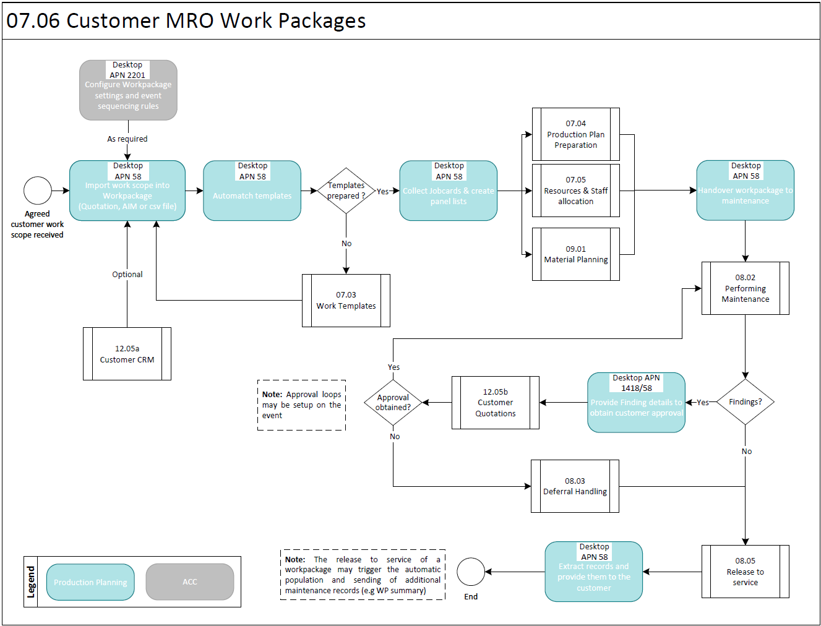

Process Flow Notes:
- It is necessary to receive Workscope from the customer in due time in order to be able to create a Customer Workpackage
- The format can be easily change into a standard txt file but it important to clarify with potential customer that the content of a Workscope should be MPD items related only. Customized Task reference will result in an extended time to prepare the Workpackage and historical data such as spend M/H and finding rates might be found difficult to manipulate.
- Worktemplate must be prepared long time in advance and only NRCs should require a preparation at the receiving of the Workscope
- The Configuration of the Work Package settings includes the definition of customised Work Package Statuses and the actions allowed for each status.
- The use of dedicated APIs allows the seamless exchange of Work Package summary and Work Package progress between the Operator’s and an external MRO’s AMOS systems.

Process Design Questions

# | Question | Answer
1 | How is the Planning Department organized? (e.g., by timeframe, by fleet, by ATA chapter, by AC type, Line/Base Maintenance, etc.)
2 | Is the same planning staff assigned with the tasks of drawing up / managing maintenance plans and arranging maintenance items into work packages?
3 | How long in advance are the first revisions of work packages released to the MRO for their preparation and execution?
4 | Are further revisions of the work packages content scheduled at fixed dates before the planned induction date?
5 | How long do work packages remain open for assigning additional items before the aircraft’s induction into maintenance?
6 | What is the capability of your internal MRO?
7 | Is there any contracted MRO for Base and/or Line maintenance? Is AMOS also the MRO software solution of choice?
8 | How long in advance is the tail assignment performed by the flight ops. Planning?
9 | What are the different statuses of a work package from its creation to its closure? Is it worth to differentiate the actions allowed / not allowed in each status? Is it worth to restrict the access to the Work Package by login / login group through different statuses in its lifecycle?
10 | Is the availability of the (internal) MRO resources a driver for the assignment of events to a work package?

Data (Source) Mapping

Data Sources | Description | Volume / Manual / Automatic / Static / Dynamic
-Nil-

Other Software Used

Other Softwares | Used by: | Description
-Nil-

AMOS Configuration

APN 2201 – Workpackage Configuration allows to define Work Package statuses and the actions allowed for each status, as well as the work package sequencing default rules, types, order and prefix.

Basic Data

Basic Data Table | Notes
wp_priority_codes | Here you can define the priorities of your workPackages.

Parameters

Parameter Code | Parameter Name | Notes | Comments / Decisions
1650 | WorkPackage Number Index | This parameter controls the automatic generation of workPackage numbers when creating workPackages.  When the integer value is > 0, an index will be appended to the generated workPackage numbers instead of the date.  When the string value is not empty it will be used as a pattern.
1264 | WORKPACKAGE SUMMARY LAYOUT | Sets the layout of the workPackage-summary report depending on the int-value.  With the string-value, default sort-order and default number of W/O-lines can be defined.  With the float value, the default amount of appended empty lines can be adjusted. | Int=0,  Float=0,  String=””
1339 | TaskCard printing and WorkPackage issue Workorder behavior | With this parameter you can decide:  - Amount [Integer]: what document should be printed (task card, WO) when printing a WorkPackage that contains TaskCard  - Amount [String]: Indicates if a WO should be issued when a Check or SRT is assigned to a WorkPackage | Int=0, String=Y;N;Y
1396 | Related Events Logic | By setting this parameter to `Y`, the Program "View/Edit WorkPackage" will also collect maintenance events that are related one to another with the relation code `W`.  When de-assigning a maintenance event from a WorkPackage, the collected related maintenance event will be as well de-assigned in case they are not themselves collected through another maintenance event that is still assigned to the workpackage. | String=Y
1470 | Workpackage Groups Settings | With this parameter you can control the behaviour of the workpackage groups. | Int=0, Float=0.00, String=””
1523 | Workpackage Assignment Restrictions | When setting the Integer value to 1, a warning message is displayed whenever a workorder classified as heavy is assigned to a workpackage classified as line. | Int=0, String=””
1640 | WP information on PDF report | This parameter gives the possibility to print workpackage information to all PDF files linked to the Workpackage Summary reports. Data is only added when printing from AMOS (either to a paper printer or PDF printer). | String=N
1653 | Forecast calculation parameters | Integer value (value in hours, value less than zero=disabled): Define a minimum Workpackage groundtime in hours to be considered as non-flying time in the expected date calculation of maintenance events.  Double value (value in days, value not defined or less than zero = default value = 15 days): It defines the number of days considered so that the forecast entries are flagged as "to be recalculated" after a counter update.  String value (value not defined or not a number format = default value = 200): Performance related - see parameter description in APN 1653 | Int=24,  Float=15,  String=200
1687 | Activate the NullLegsFiller daemon | The activation of the NullLegsFiller daemon impacts the calculation of the next due date (using counters other than calendar days) for those aircrafts with days in the past with no flight activity. Without null leg, the average daily values are applied for those days in the forecast computation. | String=Y
1748 | Automatic generation of W/P Summary report | This String parameter controls whether the W/P Summary 2 report has to be automatically generated, saved in the storage engine and linked to a W/P history entry after specific actions. | String=Y;Y
1752 | Panel Creation Configuration (Workorder/Jobcard) | The Integer value of this parameter defines whether to display the Create WO or Create Jobcard button in the Panels tab in the Production tab of View/Edit Workpackage | Int=0
1914 | Jobcard collection | The String value defines if jobcards should be collected for workpackages having an external maintenance provider. | String=Y

Workflows

Workflow Number | Workflow Name | Notes
43 | Publish a Workpackage
98 | After saving, deleting and creating a Workpackage
158 | After deassigning Events from a Workpackage
198 | Publish Workorders in a Workpackage
307 | Before assigning Events to a Workpackage
325 | Before saving, deleting and creating a Workpackage
370 | After assigning Events to a Workpackage
371 | Before deassigning Events from a Workpackage
409 | Dataset Notification | Only if WP transfer via API is used
484 | Workpackage changed

Scheduled Tasks

Scheduled Task Reference | Frequency | Notes
Forecast Sequence, including:  EffectivityApplicabilityService  EffectivityConsistencyTask  RecalculateFutureEventsService  CheckExpiredSoftwaresTask  AircraftMaintenanceForecastService  ComponentMaintenanceForecastService  PartForecastService | Daily
AimFileImportService | Every 4 to 8 Hours | This task can be used to regularly import from a shared directory the file created by an external MRO using the ”TRANSFER MRO RESULTS” AIM Service

APIs & Interfaces

Reference | Direction | Trigger | Frequency
TRANSFER MRO WORKPACKAGE | Export | Manual or WP Status change | N/A
TRANSFER MRO RESULTS | Import | Manual, Webservice or Scheduler Task | Every 4 - 8 hours at least
EXPORT FLYDOCS MRO WORKPACKAGE | Export | Webservice, only used in conjunction with FlyDocs
EXPORT FLYDOCS WORKPACKAGE SNAPSHOT | Export | Webservice, only used in conjunction with FlyDocs
EXPORT WORKPACKAGE CUSTOMER INFORMATION | Export
EXPORT WORKPACKAGE SNAPSHOT | Export

Annex – Additional Info

-Nil-

